<https://www.youtube.com/watch?v=b_QdSemDKoU>

Little complex to understand the implementation

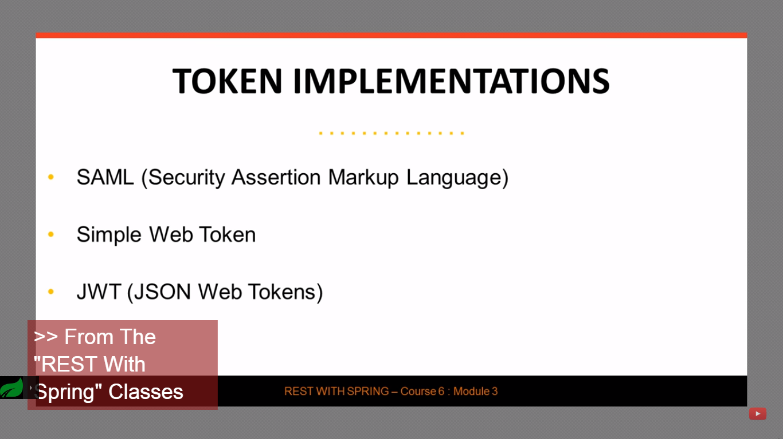

SAML – Was complex in terms of very advanced/ complex XML structures

Simple Web Token – Too simple for security

JWT – Combines features of both - Will focus more on it here.

Structure -

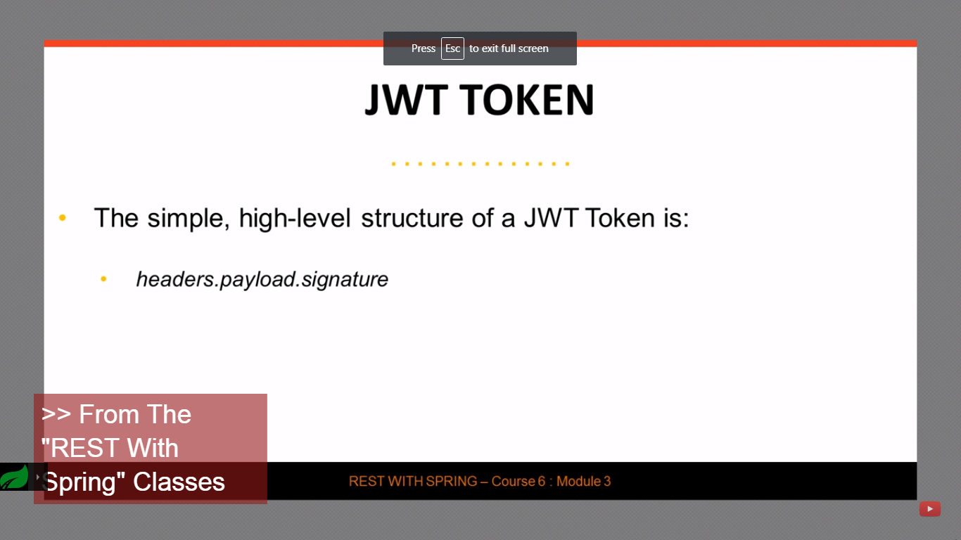

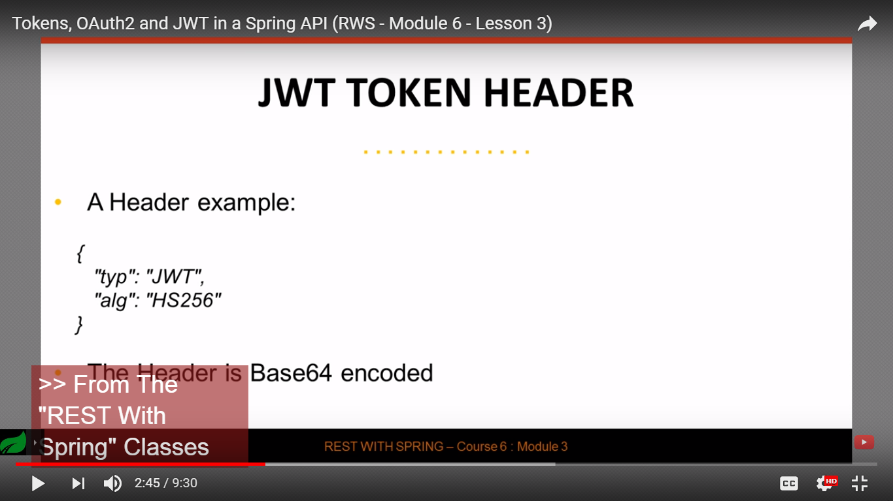

Payload -

Reserved claims – Issuer, aspiration, audience etc

Application specific claims are also supported.

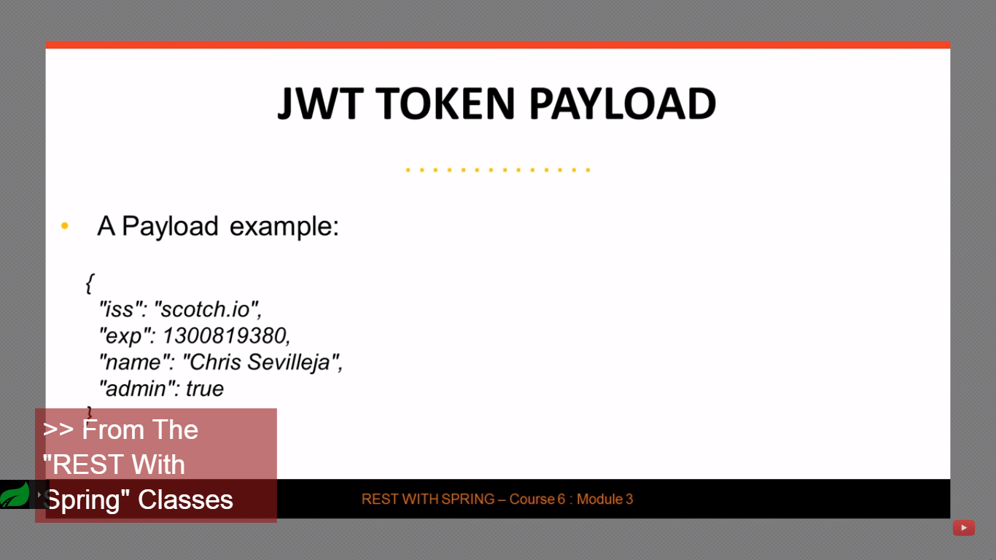

Signature –

Guarantees integrity of the token and guarantees that it has not been tampered in transit.

Both header and payload are encrypted with a secret.

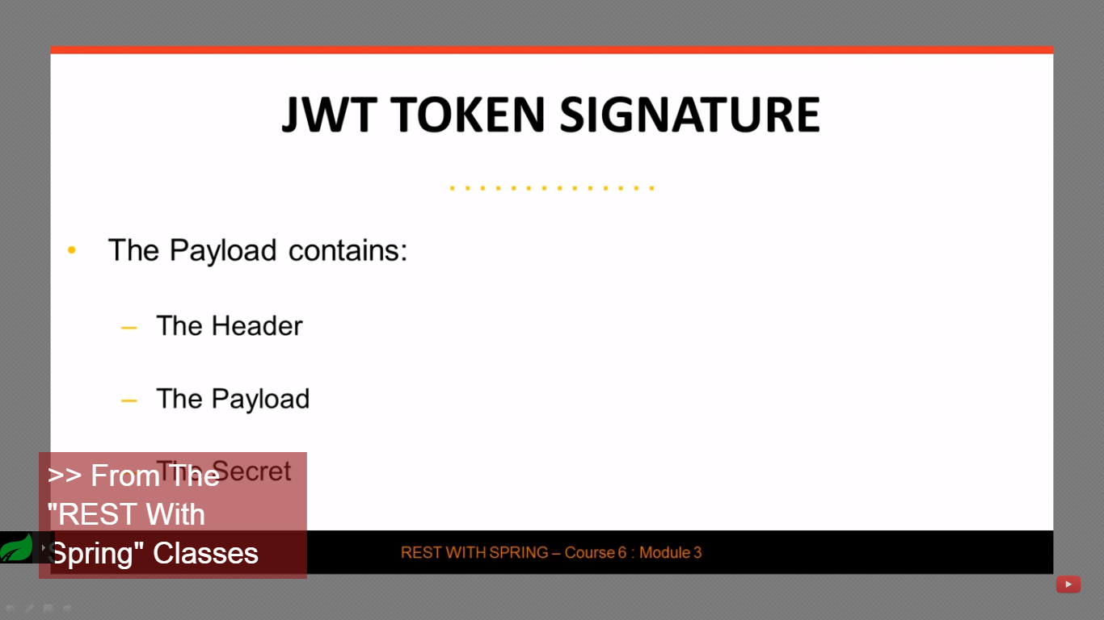

Implementation -

